**IoT based Anesthesia Control and Monitoring System**

**Mangolik Kundu, Souvik Datta and Kanimozhi. G\***

School of Electrical Engineering, VIT University, Chennai, Tamil Nadu

[Email Id:kanimozhi.g@vit.ac.in]

**Abstract:** Anesthesia influence is a state of controlled hypnosis induced during surgeries to relieve pain and to allow surgeons to carry out operations effortlessly. During surgery, an anesthetist administers a few doses of this drug as per requirement however; it has been found that human error accounts for a reasonable number of casualties. The incorrect dosage of anesthesia can cause diplopia, respiratory arrest, brain damage or even death, with their effects varying with each real-time patient. This paper presents an Automated Anesthesia Control System interfaced with a Mobile Application to allow the exchange of real-time body vitals using Internet of Things (IoT). The dosage for anesthesia is regulated by evaluating body parameters like blood pressure, heart rate, and blood oxygen level and body temperature. These readings are then sent to a microcontroller, (Arduino UNO) where it is analyzed. The appropriate dosage level will be defined by age, weight and medical history of a patient. The system can be used for any surgery involving anesthesia practice. A detailed approach is provided in reducing human errors and a convenient way is introduced in maintaining a robust record-keeping and monitoring system for any hospital. This data may then be loaded into any Cloud Storage facility for future use or accessibility. With this compact system, the fatalities prompted by human errors can be reduced.

**Keywords:** *Automated Anesthesia, Arduino UNO, Internet of Things (IoT), Cloud Storage, ESP8266, Mobile Application.*

**1. INTRODUCTION**

Anesthesia is applied to induce unconsciousness during surgery. The medicine is either inhaled through a breathing respirator or tracheal tube or delivered through an intravenous (IV) line. The primary notion of a continuous-flow Anesthesia device was publicized by Henry Boyle in 1917. Primarily, Anesthesia is further subdivided into four categories based on their area of application: (a) Local Anesthesiais defined as an agent given to momentarily reduce the sense of pain in a specific area of the body. One remains conscious once a local anesthetic is administered. For minor operations, it can be used via injection onto the site. (b) General Anesthesiais defined as an agent applied to induce unconsciousness throughout the surgery. The medicine is either inhaled through a breathing respirator or tube or given through an intravenous (IV) line. A tracheal tube may be inserted into the windpipe to support proper breathing throughout the surgery. Once the surgery is completed, the anesthesiologist stops the anesthetic and the patient is taken to the recovery room for further monitoring [5] (c) Regional Anesthesia is injected close to a bundle of nerves to numb a large region of the body (d) Neuraxial Anesthesia is placed near the spinal roots, making an even greater portion of the body numb compared to Regional Anesthesia. Epidurals are usually given to ease the pain during childbirth [10]. Since the 1940’s the specialist of Anesthesia has contributed greatly to major advances in health care [11].

Table 1. Drugs used during Intravenous and Inhaled, administration of Anesthesia

|  |  |
| --- | --- |
| **Intravenous Drugs** | **Inhaled Volatile Drugs** |
| Propofol | Nitrous Oxide |
| Midazolam | Isoflurane |
| Etomidate | Sevoflurane |
| Ketamine Diazepam | Desflurane |

Commonly used analgesic drugs originated from the family of opioids (sufentanil, remifentanil, alfentanil, morphine, fentanyl, and hydro-morphine). A patient can be connected to various electrodes to measure Electroencephalography (EEG), Electrocardiography (ECG) and Galvanic Skin Response (GSR) values. These signals while analyzed using a microcontroller can set appropriate Anesthesia doses to maintain adequate hypnosis and analgesia as shown in Figure. 1.

Anesthesia Index (AI) is obtained from EEG is used to measure the depth of hypnosis. Depth of analgesia is determined by AnalgoScore (AS), derived from ECG, and GSR Index (GI). AI value ranges from 40 to 60 is considered as representing an adequate state of hypnosis. The AS is an index that ranges from -9 to +9 and a value between -3 and +3 represents adequate analgesia. The Galvanic Skin Response (GSR) also indicates the extent of pain or pain relief of the patient. The GI is a value from 0 to 5 where 0 represents extreme pain and 5 represents no pain.

The various inputs are given to the controller which calculates the appropriate doses of anaesthetic drugs to be given to the patient. The controller can range from a simple PID controller to a more complex fuzzy controller. The controller initiates the actuator system which will administer the required propofol dose based on the AI. The analgesic drug remifentanil is administered based on the AS and GI [6].

The regulation of high or low dose of Anesthesia may cause lethal effects on the body of the patient. To dismiss any irregularities, an anaesthetist supplies a few millilitres of Anesthesia at structured intervals. But this method gives rise to its share of problems; about one-quarter of Anesthesia related failures were found to be related to human error [1]. A study between handwritten and computer-generated Anesthesia records was conducted and the result proved that readings errors affect manual anaesthetic records, may cause notable inaccuracy and may be avoided by using automated information management systems [2]. Human factors come in as important donors to critical events during Anesthesia related fatalities and this frequency can be as high as 83% [8]. Certain convolutions in the dosage of Anesthesia still linger on as the entire process is recurring and requires keen attention from the anaesthetist while being prone to human errors [7].

7% of all cases of local Anesthesia fail during general practice. Some causes for this failure include infection, wrong selection of a local anesthetic solution, technical mistakes [13]. Although Anesthesia-related mortalities have fallen from 6.4/10,000 in the 1940s to a significantly lower number at present, they can further be reduced by appropriate management [9].

Precise documentation of an anesthetic procedure is a key root of information for the assessment of dosage during surgery [3]. As the world is adopting cloud storage services, the same is chosen for our digital documentation making the data accessible from anywhere around the world. This allows the data to be secure and makes the overall system cost-efficient. So, there was a need to develop an **automatic** Anesthesia control system to minimize the errors faced. With this paper, we wanted to analyze the frequency, type and severity of equipment related problems and come out with a solution to improve safety standards. The primary use of the proposed model is to design an improved automatic Anesthesia delivery system that overcomes the disadvantages of the manual methods.

**2. PROPOSED BLOCK DIAGRAM**

The block diagram shown in Figure 2 depicts the entire working model of our project. We take various body parameters as input parameters from the patient’s body. Various sensors like the LM35 Temperature sensor are used to measure the body temperature. The MAX30100 Heart Rate and Blood Oxygen Level sensor are used to measure the heart rate and the patient’s blood oxygen level MPX5050DP Pressure Transducer is used to measure the blood pressure of the patient. These input parameters are passed on to the Arduino UNO microcontroller which then processes the input parameters and displays them on an LCD and runs the motor or the pump to inject the desired amount of Anesthesia into the patient’s body. It also sends the data to an IoT enabled mobile application so that an anaesthetist or a doctor can remotely monitor the vitals while performing surgery on the patient. The mobile application will be able to detect any abnormal vital readings and declare an ‘EMERGENCY’ and alert/notify the doctors concerned. The application will also have a separate ‘EMERGENCY’ button to explicitly invoke an emergency and alert the doctors concerned if required.

The block diagram shown in Figure. 3 depicts the working of the mobile application, the smart mobile application will help doctors/anaesthetists to remotely monitor the operation. The first page of the application will require the doctors/anaesthetists to login (refer to Figure.7 (a)) into the application with their login credentials. Figure.7(b) will direct them to a list of Categories of surgeries, once the doctor chooses an option from the list he/she will next be directed to a page containing a list of types of surgeries under that category. Once the doctor chooses the type of surgery from the list, he/she will next be directed to the page containing the list of patients he/she has for that particular type of operation on that day. After selecting the patient from the list, he/she will next be directed to the patient login page, over here the doctor will be required to login into the patient’s account with the Patient ID and the patient’s phone number. After logging in the doctor will be directed to the next page containing the patient’s details, after verifying every patient detail the doctor will be given the choice to move to the page showing the live Vitals of the patient or to the page containing the list of surgeries that the patient has undergone previously.

Once the doctor chooses from the list of surgeries that the patient has undergone previously he/she will be shown the report of the surgery, from there he/she may also move to another page showing the Anesthesia report of the patient for that particular surgery. The final page of the application will lead the doctor to the Live Vitals of the patient currently undergoing the surgery. In case of an emergency, the application will automatically detect an emergency, highlight the critical body parameters, and alert/notify the doctors in the Operation Theatre. In case if the doctor using the application wishes to raise an emergency separately he/she might click on the ‘EMERGENCY’ button provided to alert/notify the doctors in the Operation Theatre.

**3. CIRCUIT DIAGRAM OF THE PROJECT**

In Figure. 4 the Circuit Diagram of our Automated Anesthesia System depicts the overall layout of our system. We have used the Arduino UNO (ATmega328p) for managing the overall system. The Arduino UNO will receive body vitals from the various sensors and show them on the LCD Display and the IoT enabled Mobile Application and run the servo motor accordingly to pump and inject the Anesthesia into the patient. The MAX30100 Pulse Oximeter sensor has been used to measure the heart rate and blood oxygen level of the patient. An LM35 Temperature Sensor has been used to measure the body temperature of the patient and the MPX5050DP Pressure Transducer has been used to measure the blood pressure of the patient. In case the vitals become abnormal, the microcontroller will check it and show an ‘EMERGENCY’ message on the Mobile Application and notify the doctors.

The ESP8266 WIFI Module is required to communicate with the Remote Mobile Application. All the components in the circuit diagram work at 5V power supply except for the ESP8266 Wifi Module which works at 3.3.V and the LEDs which work at 3V. 3 LEDs have been used to depict the various blood pressure levels and conditions. A Red LED has been used to indicate a LOW BP(Hypo) condition, a Green LED has been used to indicate the NORMAL and Pre-Hyper conditions and a Blue LED has been used to indicate the S1 Hyper, S2 hyper and Hyper Crisis conditions.

**4. FLOWCHART :**

The body temperature of the patient is captured by the LM35 Temperature Sensor, the blood pressure of the patient is captured by the MPX5050DP Pressure Sensor, the heart rate and the blood oxygen level of the patient is captured by the MAX30100 Pulse Oximeter Sensor. These inputs are given to the Arduino UNO microprocessor, if all the input body parameters satisfy the medical conditions then the Arduino UNO runs the DC Servo Motor via the L293D Motor Driver. A syringe containing Anesthesia is connected to the DC Servo Motor so that as soon as the motor runs the syringe injects the Anesthesia into the patient’s body. The Arduino UNO also displays the input body parameters(vitals) of the patient on an LCD Display and the vitals are also sent in real-time to the IoT enabled smart mobile application for remote monitoring of the patient. If while remote monitoring of the patient a critical or emergency condition arises the mobile application will highlight the abnormal readings and raise an auto-generated emergency thus alerting and notifying the doctor present in the Operation Theatre. In case, the anaesthetist or the doctor in charge remotely monitoring the operation wants to invoke an emergency separately and manually stop the Anesthesia administration system, he/she may click the ‘EMERGENCY’ button provided on the Mobile Application to do so thus, also alerting the doctors present in the Operation Theatre.

**5. HARDWARE DEVELOPMENT**

The components required for prototype design is shown in Table.2 and the details are shown below:

Table 2. The components required

|  |  |
| --- | --- |
| **COMPONENTS USED** | **QUANTITY** |
| Arduino UNO | 1 |
| 100K Potentiometer | 1 |
| 10K Potentiometer | 2 |
| Resistors | 4 |
| Heart Rate and Oximeter Sensor-MAX30100 | 1 |
| LCD Display-16x2 | 1 |
| Adafruit 0.96’’OLED Display | 1 |
| L293D - Motor Driver | 1 |
| DC Servo Motor | 1 |
| Temperature Sensor - LM35 | 1 |
| LEDs | 2 |
| Jumper Wires | - |
| ESP8266 | 1 |
| Pressure Transducer MPX5050DP | 1 |

* **Arduino UNO** - It is a microcontroller board based on the ATmega328P chip using Arduino Programming Language and running on Arduino IDE. The Arduino Programming Language is a lot similar to C++ Programming. The board runs on 7.5 - 12V. It comprises six analog inputs, fourteen digital input and output pins, a USB connection for power and data transfer and a reset button [14].
* **Heart Rate and Oximeter (MAX30100)** - It comprises 2 LEDs transmitting waves in-
* Infrared Spectrum (950nm)
* Red Spectrum (650nm)

This sensor can be placed anyplace where the skin slim enough for light of both frequencies to

steadily infiltrate the tissue. Once both of them have passed through the skin, their absorption

is measured using a photodiode. The ratio between the absorbed Red Light and IR Light will

be varying depending on the amount of oxygen in the blood. Using this ratio, it is possible to

calculate the oxygen level in haemoglobin [15].

* **L293D Motor Driver** - It is a dual H-bridge driver integrated circuit that acts as a current amplifier. The amplified signal is used to drive the servo motors. Its electronic circuitry allows a voltage to be administered over a load in both directions [16]. This component allows the Arduino UNO to drive two servo motors simultaneously and in both anticlockwise and clockwise direction.
* **Temperature Sensor (LM35)** - It is a precision IC temperature device from the LM35 series with an output voltage linearly proportional to the centigrade temperature. These devices do not require any external calibration and can render average accuracy of ±¼°C at room temperature [17].
* **ESP8266** - It is a low-cost WIFI Module integrated with a 32-bit Tensilica L-106

Microcontroller which highlights extremely low power consumption [18]. This component allows the Arduino UNO to be IoT enabled.

* **MPX5050DP Pressure Transducer** - MPX5050 is a high-precise pressure sensor used to measure pressure and is widely used in the fields of Medical Instruments. It is a dual-port, differential integrated silicon pressure sensor in a 6 pin System-in-Package (SIP) package. It is a monolithic silicon pressure sensor used to provide an accurate and high-level analog output signal that is proportional to applied pressure [19].

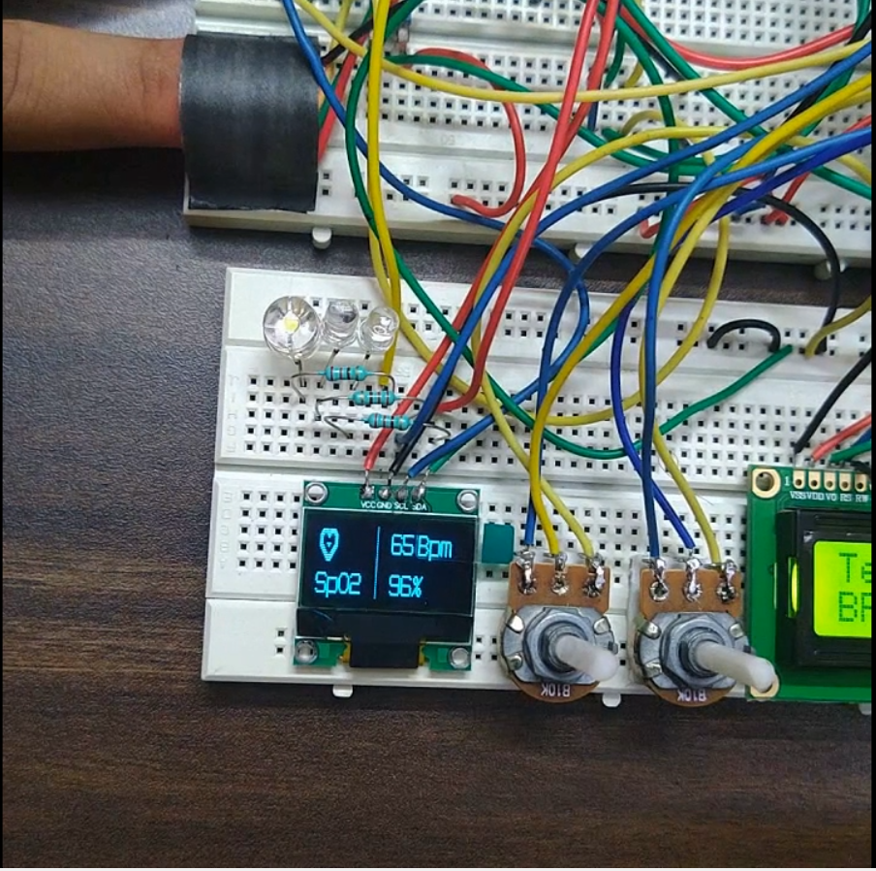

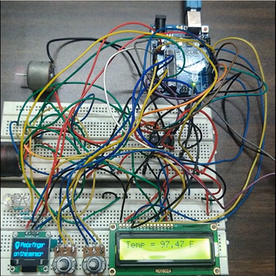

**(a) (b)**

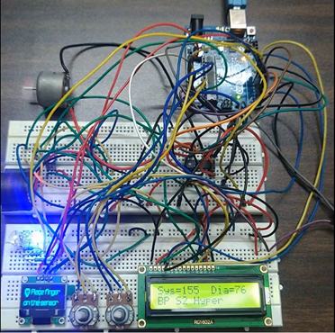 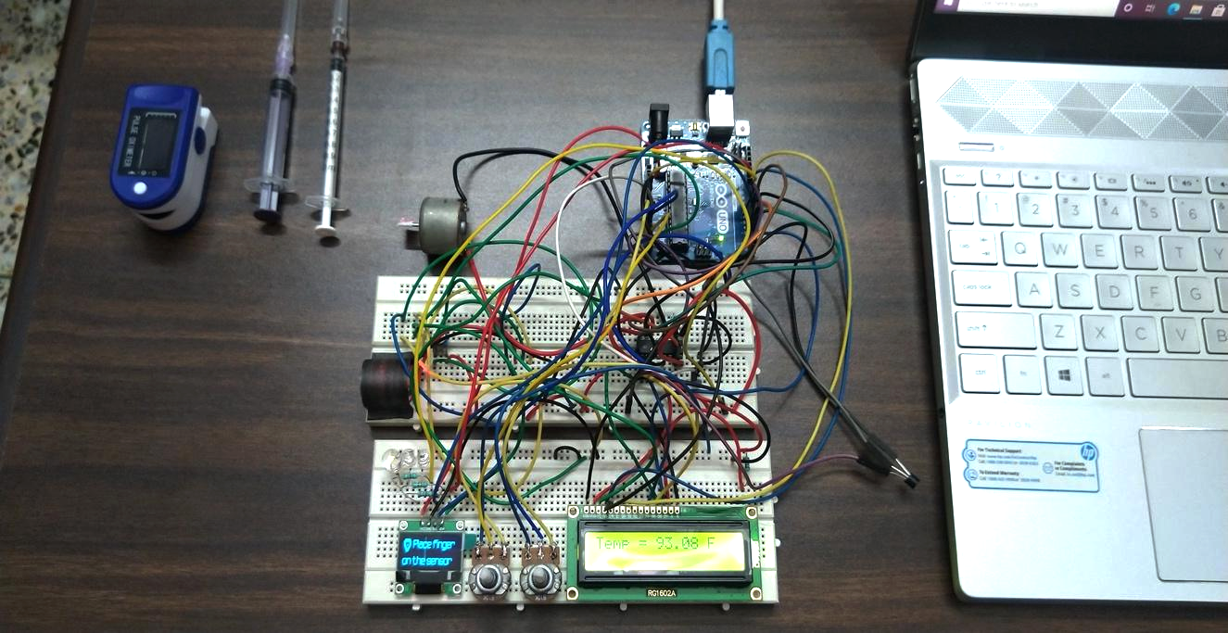

**(c) (d)**

Figure. 6(a),(b),(c) Images of the hardware throughout the development of the project and

(d) Prototype with the Sensors, Microcontroller and a Syringe respectively.

The proposed prototype usesMAX30100 for measuring heart rate and Blood Oxygen Level (SpO2), LM-35 for measuring body temperature, and MPX2050DP pressure transducer for measuring Blood Pressure. The Arduino UNO is interfaced with all the aforementioned sensors to display readings on a 16X2 LCD Display and Adafruit 0.96’’OLED Display. The Micro Servo Motor is connected to a syringe carrying an anesthetic drug.

**6. IoT/ Mobile Application User Interface (UI) -**

The IoT linked Mobile Application is a very convenient way devised to keep the anesthesiologists updated on Live Vitals as well as patient history giving him/her a complete insight about the patient and the respective operation. As we enter the Application, the respective doctor is advised to Log-In first to maintain privacy with patient details as presented in Figure.7 (a). A doctor log in using a case sensitive password and on successful authentication is transferred to the page of Surgery Category as portrayed in Figure.7 (b). This page allows the doctor to select a type of surgery to administer. The purpose of adding this feature was to allow smooth accessibility to a particular patient in a logical sequence instead of having to remember every surgery detail to get access to the patient. On selecting the type of surgery the doctor is then introduced to a subcategory of the type of surgery he/she had previously selected. The case of Cardiology with subcategories as Coronary Bypass Surgery, Angioplasty and Valvuloplasty is taken as sample as revealed in Figure.7(c).

IfCoronary Bypass Surgery is selected, the doctor is introduced to his active patients as shown in Figure.8(a). The doctor is then required to select his particular patient based on Surgery type and asked to Log-In using the Patient Unique ID or Patient Phone Number as shown in Figure.8 (b). In case the patient isn't registered on the mobile application, a provision to create a new account has also been implemented. On successful login, the doctor can now get a comprehensive impression about his/her patient as shown in Figure.8(c). The following page also hosts the option to proceed to live vitals or patient surgery history. In case the doctor wishes to get a brief on the patient's surgery history, he/she can simply select that option and is taken to the patient history page as shown in Figure.9(c). On selecting a particular operation date and type the doctor is presented with a detailed Medical Report as shown in Figure.10 (a). The page also gives the doctor the option to view the Anesthesia Report for that particular surgery as shown in Figure.10(c). After careful examination of the patient's history, the doctor can visit the Live Vitals page as shown in Figure.11(a).

The Live Vitals page shows the patients’ heart rate, body temperature (F), Oxygen Level (SpO2) and Systolic and Diastolic Pressure. The Live Vitals page exhibits a different user interface for Emergency and Normal conditions as shown in Figure.11 (b) and 11(c) respectively. During an auto-detected emergency condition, the doctors in the Operation Theatre are alerted as shown in Figure.11(c). A provision has been allocated for Manual Emergency Action with the help of a button as shown in Figure.11 (b).

**7. CONCLUSION**

A device has been developed that automatically monitors the patient's vital signs and prescribe the necessary amount of anesthesia as required. This system will not eliminate the need for an anesthesiologist but permits to perform his/her job better and safer. Automation of Anesthesia for monitoring vital functions is desirable as it will provide more time and flexibility for the anesthesiologist to focus on critical issues. The system is extremely accurate and responsive (up to 98%). These parameters determine the overall condition of the patient. In case the vitals drop below the desired level, the Anesthesia dosage is controlled automatically with the help of the microcontroller and the motor actions. The syringe infusion pump is mechanically connected to the motor. The required level of Anesthesia is exactly calculated and administered so that future side effects due to variations in Anesthesia levels are eliminated. The data is reliable and can be effectively tracked with the aid of a robust record-keeping and IoT enabled system.

**References**

1. Fasting, S., & Gisvold, S. E. (2002). *Equipment problems during Anesthesia—are they a quality problem? British Journal of Anesthesia, 89(6), 825–831.*
2. Thrush, D. N. (1992). *Are automated anesthesia records better? Journal of Clinical Anesthesia, 4(5), 386–389.*
3. Heinrichs, W. (1995). *Automated Anesthesia record systems, observations on future trends of development. International Journal of Clinical Monitoring and Computing, 12(1), 17–20.*
4. Suttipongkeat, S. (2019, March 11). *Case study: Successful removal of broken coronary angioplasty balloon from left main coronary artery*. <https://www.pcronline.com/Cases-resources-images/Complications/Implant-loss/Coronary-embolised-devices/balloon-fracture/Case-library/Case-study-successful-removal-of-broken-coronary-angioplasty-balloon-from-left-main-coronary-artery>.
5. *Anesthesia*. (n.d.). Johns Hopkins Medicine. Retrieved April 3, 2021, from https://www.hopkinsmedicine.org/health/treatment-tests-and-therapies/types-of-anesthesia-and-your-anesthesiologist.
6. Kudva, H. (2014). Automated Anesthesia Delivery Pump. *IOSR Journal of Pharmacy and Biological Sciences*, *9*(4), 100–106.
7. Krishnakumar, S., Bethanney Janney, J., Antony Josephine Snowfy, W., Joshin Sharon, S., & Vinodh Kumar, S. (2018). *Automatic anesthesia regularization system (AARS) with patient monitoring modules. International Journal of Engineering & Technology, 7(2.25), 48.*
8. Chandran R, DeSousa KA. *Human factors in the anaesthetic crisis.* World J Anesthesiol 2014; 3(3): 203-212.
9. Gottschalk, A., Van Aken, H., Zenz, M., & Standl, T. *Is anesthesia dangerous?* Deutsches Arzteblatt International (2011), 108(27), 469–474.
10. Harvard Health Publishing. (2015, May 10). *What you should know about anesthesia*. Harvard Health.<https://www.health.harvard.edu/diseases-and-conditions/what-you-should-know-about-anesthesia#:~:text=Anesthesiologists%20use%20a%20combination%20of,her%20to%20help%20you%20breathe.>
11. Miller, R. D., & Pardo, M. (2011). *Basics of anesthesia e-book*. Elsevier Health Sciences.
12. American Society of Anesthesiologists. (n.d.).*Case Studies - Patient Stories and Improvement Stories*. Retrieved April 5, 2021, from<https://www.asahq.org/brainhealthinitiative/casestudies>
13. Vinckier, F. (2000). What is the cause of failure of local anesthesia? *Revue belge de medecine dentaire*, *55*(1), 41-50.
14. Galadima, A. A. (2014, September). Arduino as a learning tool. In *2014 11th International Conference on Electronics, Computer and Computation (ICECCO)* (pp. 1-4). IEEE.
15. Strogonovs, R. (2017). Implementing pulse oximeter using MAX30100. *Morf-Coding and Engineering*.
16. Srikanth, V., Prasad, G., Chakrapani, B. C., Jaswanth, S., Shankar, V. R., & Sridhar, P. Microcontroller Based Speed Control of a DC Motor Using PWM Technique. *International Journal of Advanced Trends in Computer Science and Engineering*, *5*(1), 124-127.
17. *LM35 Temperature Sensor*. (n.d.). © 2018 ElectronicWings. Retrieved April 7, 2021, from <https://www.electronicwings.com/components/lm35-temperature-sensor>
18. Kodali, R. K., & Mahesh, K. S. (2016, December). Low-cost ambient monitoring using ESP8266. In *2016 2nd International Conference on Contemporary Computing and Informatics (IC3I)* (pp. 779-782). IEEE.
19. O. Information, “Freescale Semiconductor Integrated Silicon Pressure Sensor On-Chip Signal Conditioned, Temperature Compensated and Calibrated,” pp. 2007–2010, 2010.

**Figure legends:**

Figure 1. Diagram representing the workflow of the system

Figure 2. Block Diagram depicting the operation of the system

Figure 3 Working of the Mobile Application

Figure 4. Circuit diagram made using Fritzing

Figure 5. Flowchart of the system

Figure 6(a),(b),(c) Images of the hardware depicting Blood pressure, temperature and vital parameters and (d) Prototype with the Sensors, Microcontroller and a Syringe respectively

Figure.7 (a) Doctor Login Page (b) Surgery Category Page (c) Type of Surgery Page

Figure.8 (a) Patient List Page (b) Patient Login Page (c) Patient Details Page

Figure 9 (a) Patient Details Page (b) Patient Details Page (c) Patient Surgery History Page

Figure 10 (a) Patient Medical History Page (b) Patient Medical History Page (c) Anesthesia Report page

Figure 11(a) Patient Vitals Page (b)Patient Vitals Page **(c)** Patient Vitals Page

Pardo, Manuel, and Ronald D. Miller. *Basics of Anesthesia E-Book*. Elsevier, 2017.

“Patient Stories and Improvement Stories.” Accessed May 12, 2021. https://www.asahq.org/brainhealthinitiative/casestudies.

Vinckier, F. (2000). What is the cause of failure of local anesthesia? *Revue belge de medecine dentaire*, *55*(1), 41-50.

Galadima, Ahmad Adamu. “Arduino as a Learning Tool.” *2014 11th International Conference on Electronics, Computer and Computation (ICECCO)*, 2014. https://doi.org/10.1109/icecco.2014.6997577.

Strogonovs, R. (2017). Implementing pulse oximeter using MAX30100. *Morf-Coding and Engineering*.

S.M.Bakibillah, A., Nazibur Rahman, and Md. Anis Uz Zaman. “Microcontroller Based Closed Loop Speed Control of DC Motor Using PWM Technique.” *International Journal of Computer Applications* 108, no. 14 (2014): 15–18. https://doi.org/10.5120/18979-0402.

“LM35 Temperature Sensor.” ElectronicWings. Accessed May 12, 2021. https://www.electronicwings.com/components/lm35-temperature-sensor.

Kodali, Ravi Kishore, and Kopulwar Shishir Mahesh. “Low Cost Ambient Monitoring Using ESP8266.” *2016 2nd International Conference on Contemporary Computing and Informatics (IC3I)*, 2016. https://doi.org/10.1109/ic3i.2016.7918788.

O. Information, “Freescale Semiconductor Integrated Silicon Pressure Sensor On-Chip Signal Conditioned, Temperature Compensated and Calibrated,” pp. 2007–2010, 2010.